Waterfall Model
A linear and sequential SDLC model where each phase must be completed before moving to the next. It does not allow going back to previous stages and is suitable for small, well-defined projects.
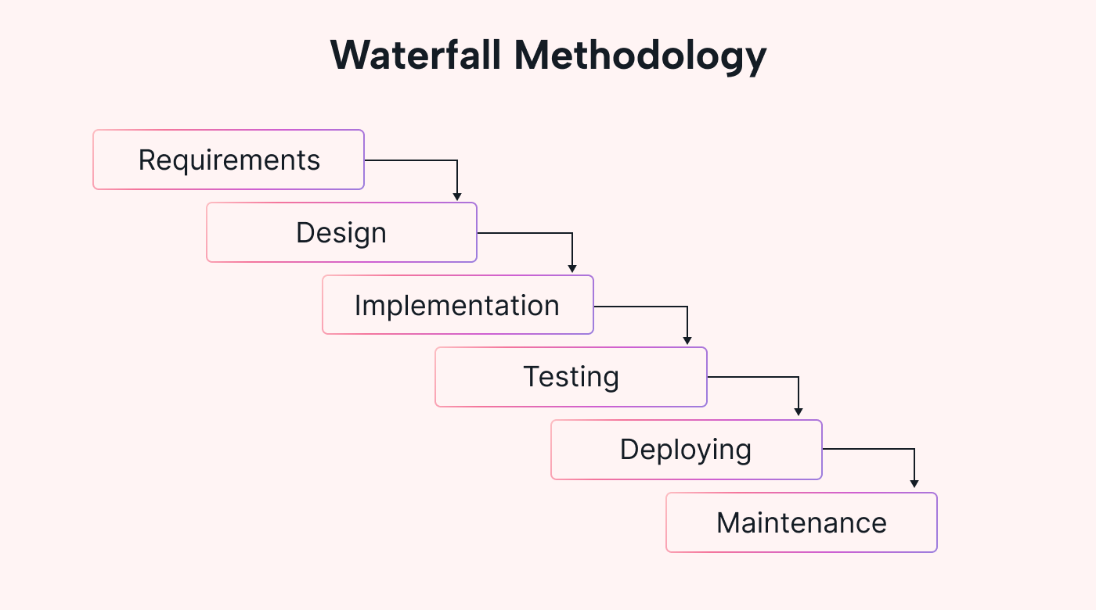
Here are each Waterfall phase is described:
- Requirement Gathering: Collect all client requirements clearly at the start with no changes allowed later.
- System Design: Prepare the architecture, technology selection, and overall system structure.
- Implementation (Coding): Developers build the entire software according to the design document.
- Testing: Testers check the completed software for bugs and ensure it works as expected.
- Deployment: The finished software is delivered or released for actual use.
- Maintenance: Fix post-release issues, provide updates, and support the users.

Agile Methodology
Agile is a flexible, fast, and iterative way of developing software.
Instead of building the entire product at once, Agile divides the work into small parts called Sprints (usually 2–4 weeks).
At the end of each sprint, a working feature is delivered, tested, and reviewed by the customer. Unlike Waterfall, Agile allows and welcomes requirement changes even in the middle of the project.
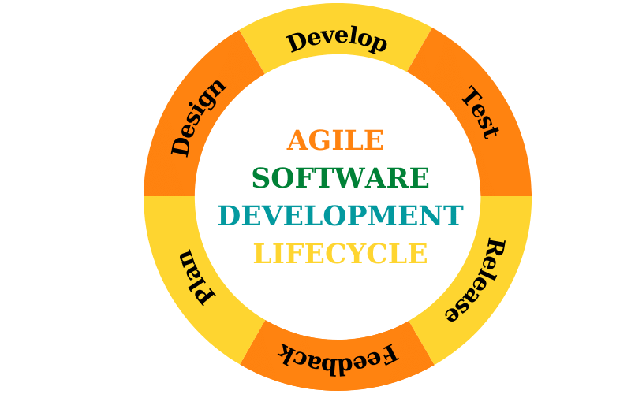
1.Requirement Gathering (Backlog Creation)
Collect high-level requirements and list them as user stories in the product backlog.
Requirements can change anytime and are updated continuously.
2. Sprint Planning
The team selects which tasks/features to complete in the upcoming sprint.
Each item is broken into smaller tasks with clear goals.
3. Design + Development (During Sprint)
The team designs and builds only the selected features for that sprint.
Work is done in short cycles to deliver small, usable parts of the product.
4. Testing (Within the Same Sprint)
Testers check the new features immediately as they are developed.
Bugs are fixed instantly to maintain quality.
5. Sprint Review
The completed features are demonstrated to the client or stakeholders.
Feedback is collected and added to the backlog if needed.
6. Sprint Retrospective
The team discusses what went well and what needs improvement.
Changes are applied in the next sprint to improve efficiency.

V-Model (Validation and Verification Model)
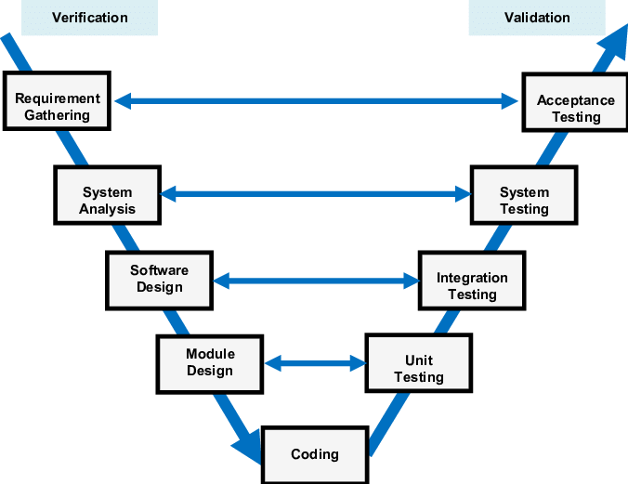
The V-Model is an SDLC model where each development phase has a matching testing phase. It looks like the letter “V” — development on the left side, coding at the bottom, testing on the right side.
Verification Phases (Left Side of V)
1. Requirement Analysis
Understand what the customer wants and document all requirements.
2. System Design
Plan the overall system: modules, data flow, architecture.
3. Architectural Design
Break the system into high-level components and define interactions.
4. Module/Unit Design
Design each module or component in detail.

Validation Phases (Right Side of V)
5. Unit Testing
Test each module to ensure it works correctly.
6. Integration Testing
Test how modules work together when combined.
7. System Testing
Test the full system to check performance, security, and functionality.
8. Acceptance Testing
Client tests the final system to ensure it meets requirements.

Spiral Model
The Spiral Model is a risk-driven and iterative software development model.
The project is developed in multiple loops called spirals, and each spiral adds more features.
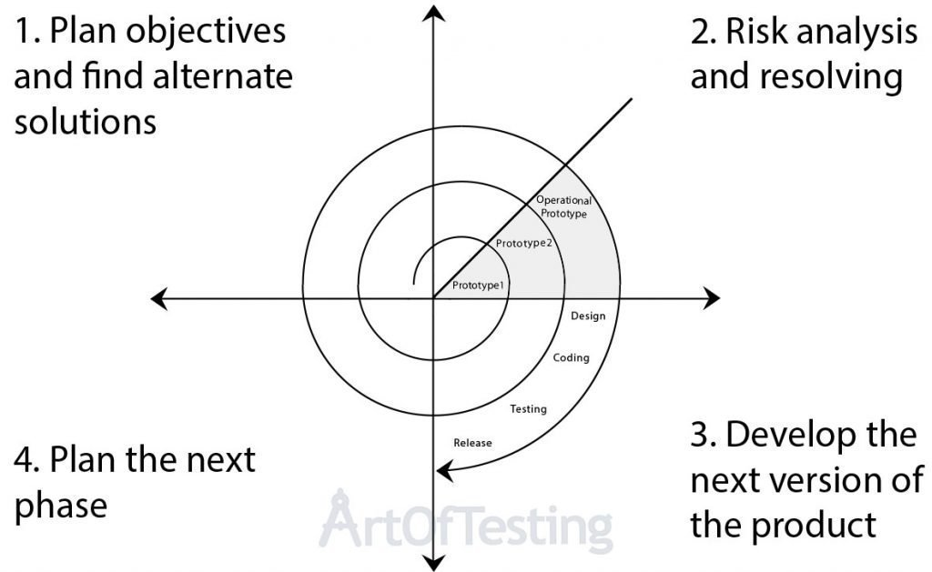
Four Phases in Each Spiral
1. Planning
Gather requirements, set objectives, and estimate cost and schedule.
2. Risk Analysis (Most Important)
Identify risks, analyze possible failures, and build prototypes to reduce risks.
3. Development
Build the selected features for that spiral — includes design, coding, and testing.
4. Evaluation
Customer reviews the output, gives feedback, and decisions are made for the next spiral.

